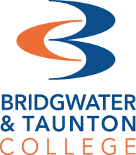

A Level Art & Design

Lecturers
Joe Coleman colemanj@btc.ac.uk joetimothycoleman.com
Jeremy Layton laytonj@btc.ac.uk @redfishillustrations
Katie Court courtk@btc.ac.uk
Keep in touch
Follow our instagram account to see what our current students are working at @btc_artdesign1

Theme - IDENTITY
Art & design at A Level is about expression. Moving forward from GCSEs, your projects are going to rely on your own sensibilities to translate topics and pick themes. In the second year, your major project will be of a topic of your choosing. Therefore, your identity is crucial to exploring this. This is a great opportunity for us to get to know you.

Activity 1 - Record
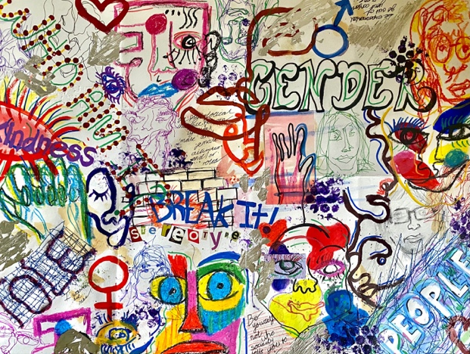
Consider what is important to you, as a person, a creative, and as a maturing student. Consider topics around current world issues, interesting facts/ideas, personal beliefs.
- Decide on your inspiration - based around something you like/enjoy or about you as a person/ identity in general. Mindmaps like the one here are great for throwing lots of ideas out at the start
- Collect visuals around one of these themes
For example, produce a mood board/take photos/ create drawings of objects etc. This could be first-hand or collected eg. internet/magazine imagery.
Collage can be a fun way of piecing together ideas visually. Lay pieces out before sticking down and plan to fill in the gaps with sketching/painting…
You could collate all your recordings into a mini sketchbook, or, tie loose pages together to create your own. If you enjoy working on a larger scale why not create a large map piece like the one
above - we recommend a minimum size of A2 for this (you could tape four pieces of A4 paper or two A3 together to achieve this size)

Activity 2 - Develop
Explore and visualise how your ideas could become outcomes. These are more refined than early ideas. This refinement will involve looking at your Activity one work and thinking of ways to improve and extend. Think about Scale, materials, time, theme, and research- be ambitious and brave!
You could produce:
- Drawing/painting - this could be observational of an important artefact/object. It could be anatomical such as a portrait, self-portrait or a response to the body in another way.
- Collage - you could look at the work of Kurt Shwitters for something abstract, or Hannah Hoch for something political and playful as a starting point.
- 3d work - sculpture- clay/plasticine, construction (card/paper). These are quick ways of making 3D work at home by raiding the recycling for great found objects. Great for environmentally concerned students…
- Print - here’s a great tutorial on monoprinting at home! (in it, they use a sheet of glass, you could replace this with anything flat, even a baking tray!)
https://www.craftsy.com/post/how-to-monoprint/

Alternative to a finished outcome, you could attempt to create a set of experiments of the above, spending some time on more than one. This is a great way to extend early ideas before committing. This will take more time and resources potentially, but the focus is on play!
Please make with what you have available, as lecturers we are missing the facilities as much as our students! We all have to be inventive!
Email your work to Joe at colemanj@btc.ac.uk
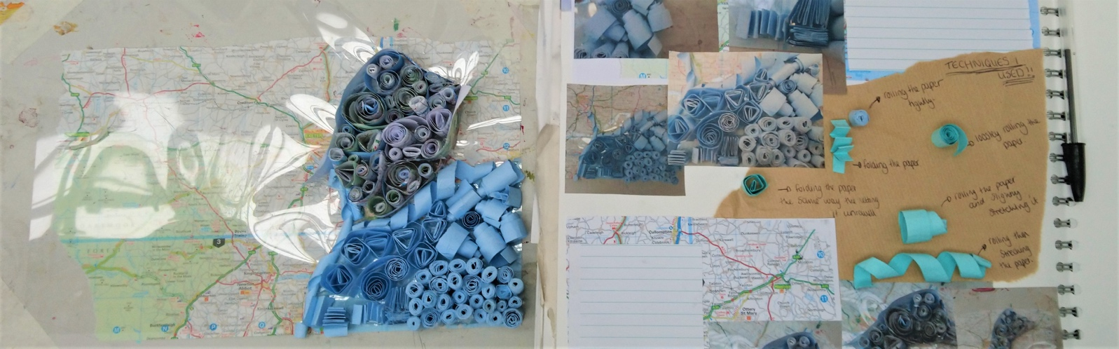

Frequently asked questions
How is the subject assessed?
Art & Design is assessed via two components. The first is a personal investigation project that consists of a practical portfolio of work and a related study (critical written element). The second is an externally set project that culminates in a 15-hour practical exam. All work is internally assessed and moderated by the exam board.
Throughout the course, we will thoroughly prepare you through practical workshops, project development, written tasks and group critiques.

Are there lots of techniques to learn?
Yes. Throughout year one we will introduce you to 2D drawing/painting/printing/collage and 3D casting/construction/modelling/carving and advanced fine art methods- installation and time-based work.

Do I need to be good at drawing?
Everybody is far better at drawing than they think they are! Rather than measuring your skills,
we want you to practise every single day! It doesn’t have to be an A3 masterpiece, just reflect your love of it.

Do I need to have taken Art at GCSE?
No. An arts subject is preferable, but we understand that not all creative subjects are now offered by secondary schools, or that your options may have clashed. You must bring an enthusiasm for the subject though, and willingness to learn and experiment.

Can I choose my own themes to work with?
Yes and no! In year 1, the staff team will give you ‘set themes’ as this enables us to run lots of skill building, specific technique workshops. However, we expect each student to come up with a personal response to the set theme, so you can certainly take your project in a direction of personal interest.
In year 2 you are required to choose your theme yourself for the personal investigation component, so this is completely up to you. For the externally set task you have a range of theme starting points to choose from (set by the awarding body).

What other subjects does A Level Art & Design go with?
A Level Art & Design will not only enable you to learn subject specific practical abilities, but will develop key transferable skills including critical analysis, problem solving and creative thinking.
It is a very versatile subject that compliments study of many other areas. A Level Art & Design students often study alongside subjects such as English, Business, History, Sociology, Psychology, Media and Sciences.

Is it possible to study A level Art & Design with another ‘Arts’ subject?
Yes. We have had lots of students study A Level Art & Design alongside Fashion and Textiles, Photography and Media in the past. However, you should carefully consider the time commitment of taking two ‘sketchbook’ subjects and bear in mind that often project timelines are the same as we work to either the same or similar specifications. It may be that rather than taking two Arts A Level subjects a vocational program could suit you better. Visit the website or contact us to discuss the options available eg. Level 3 Art & Design or Level 3 Fashion Business. These courses are full-time and equivalent to three A Levels.

