A Level Business

Lecturer
Sabrina Schmidt schmidts@btc.ac.uk

Activity 1 - Find the term

Read the explanations in the table below and see whether you can think of the correct term described.

Once you have tried and find you may need a hint, go to the next page. You find the terms there. Check with the ones you thought of yourself and then see that you fill in the ‘blanks’ and match all terms to the explanations.

Explanation | Term
That situation that results when an employee’s contract of employment is ended because that job no longer exists (due to new technology for example) or is no longer needed due to a down turn in demand.
An attribute required of anyone in charge of a group of people. It may involve people having certain traits such as intelligence and initiative.
Styles can be:
Democratic Tony Blair
Autocratic Hitler
Laissez-faire Letting people get on with it
The joining together of two or more firms. This might be because one business has taken over another or because two firms have agreed to join. There are several types including horizontal, vertical, lateral and conglomerate.
A type of long-term finance used to buy property. Normally this is paid back over 25 years.
The reason or incentive for doing something. It is especially important when assessing the reasons why people work. An owner or manager of a business needs to be aware of ways of motivating individuals at work to make the best use of the factor of production and labour.
The excess of cash allowed by a bank to a business or personal customer, permitting the withdrawal of more from a current account that is there, up to a limit. The customer may pay interest on that amount. It is used as a short-term method of finance.
The process by which an organisation transforms raw materials using financial and human resources into a product that is consumed by someone else.
A price set to encourage customers to believe they are gaining an advantage
i.e £9.99 not £10.

Hints
The terms that need allocation and matching:
- Overdraft
- Production
- Merger
- Psychological Pricing
- Redundancy
- Leadership
- Mortgage
- Motivation

Activity 2 - Crossword challenge
See whether you can detect the businesses that use the below slogans in their advertising campaigns.
Try to not use the internet

Across Downxxxxxxxxxxxxxxxxxxxxxxxxxxxx
2. Buy it. Sell it. Love it. 1. It’s in the game
4. Let’s make things better 3. The king of beer
7. Come on, let’s fly 5. A car you can believe in
9. See what you can do 6. Don’t worry. There’s no sugar.
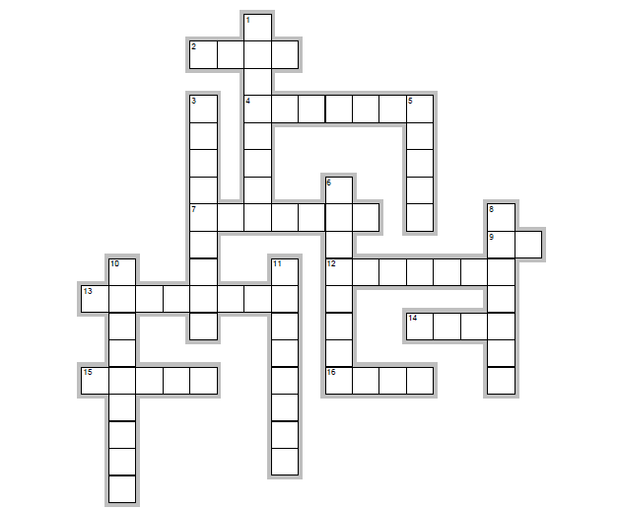
13. Wii would like to play 8. Australian for beer
15. Connecting people 10. Where do you want to go today
16. It’s good to play together 11. HelloMoto

