A Level Chemistry

Lecturer
Magda Haines pospiesznahainesm@btc.ac.uk

Activity 1 – Titration simulation
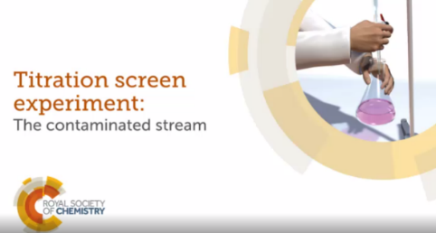
Register on the Royal Society of Chemistry website. You only need to enter your name or initials and you will be given your own number. It is a brilliant titration activity, whether you have done one in school or not. I would like you to do at least Level 1 and 2. You can even print the pdf of your lab book.

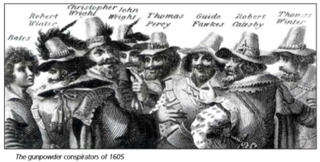
Activity 2 – The chemistry behind fireworks

Watch these two demos of a flame test
https://www.youtube.com/watch?v=1EXr_L7Ojqg
https://www.youtube.com/watch?v=TOyDzOc2AaI

Complete the Chemical elements in fireworks table (below) by adding the missing element names, symbols and colours. Then work out and fill in which elements are metals and which are non-metals. Use a Periodic Table to help you if necessary.

Chemical element | Symbol | Metal/Non-Metal? | What it does in fireworks
Lithium | ……… | ……………… | Colour agent - ………………………..
……………… | Na | ……………… | Colour agent - gold and yellow
……………… | K | ……………… | Fuel and orange - red sparks; colouring agent - ………………………
Magnesium | ……… | ……………… | Fuel and bright white flames
Calcium | ……… | ……………… | Colour enhancer - helps make colours deeper; colouring agent - ………………………………….
……………… | Sr | ……………… | Colouring agent - red (crimson)
Barium | ……… | ……………… | Colouring agent - green
Titanium | ……… | ……………… | Fuel and produces silver-white sparks
……………… | Fe | ……………… | Produces gold coloured sparks
……………… | Cu | ……………… | Colouring agent - ……………………….
Zinc | ……… | ……………… | Fuel and smoke agent
Aluminium | ……… | ……………… | Fuel and makes yellow-white sparks  eg in sparklers
……………… | C | ……………… | Fuel, component of black powder
……………… | Sb | ……………… | Fuel, glitter effects
Sulfur | ……… | ……………… | Fuel, component of black powder

Which chemical elements could be combined in a firework to make the following?
  - Turquoise? ………………………

  - Violet? ………………………

  - Citron (pale yellow) ………………………
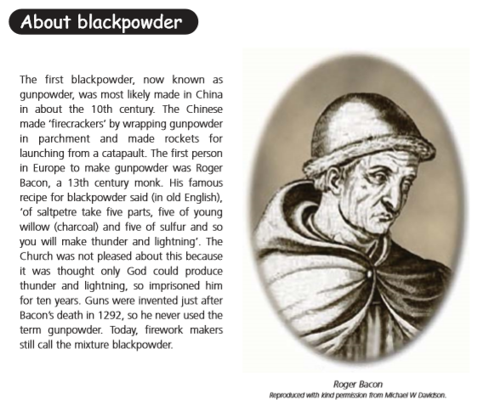

Investigating blackpowder
Blackpowder is a mixture of three things so the reaction is complicated. Watch the demonstration, which shows how blackpowder works.
Results
Write down what you saw.

Questions
- Write down the formulae of the chemicals in the experiment.
- Which chemical is acting as the fuel?
- Which chemical supplies oxygen?
- Complete the word equations for these two reactions:
carbon + oxygen  
sulfur + oxygen  

Are the products of these two reactions solids, liquids or gases at room temperature?
- Why does the explosion happen?

Frequently asked questions about A Level Chemistry
How is this subject assessed?
A Level Chemistry is assessed via three exam papers at the end of year 2. Throughout the course, we will thoroughly prepare you for the exams with skills development, exemplar answers and practice questions. Practical skills are also assessed through exams.

How many practicals will I do?
You will need to demonstrate various skills in the minimum of 12 practical activities across two years.

What extra-curricular opportunities are there?
In recent years we have had guest speakers, a “Spectroscopy in a Suitcase” workshop run by the Outreach Ambassadors from Bristol and Bath Universities. Every year our students participate in Chemistry Olympiad.

What other subjects does A Level Chemistry go with?
Chemistry students very often choose other science subjects, such as biology, physics or psychology as well as maths and geography.

Recommended Reading
Royal Society of Chemistry
Science News for Students
Chemistry World

https://www.compoundchem.com/infographics/

Recommended Listening
Chemistry World podcasts

Periodic Table podcasts

