A Level Dance

Course Leader
Jake Elson elsonj@btc.ac.uk
Teaching team
Kate Golder golderk@btc.ac.uk
Amy Wigglesworth wiggleswortha@btc.ac.uk
Key Information
2 years / Assessment is via practical and written exams

Activity 1 – ‘Go’ to the theatre
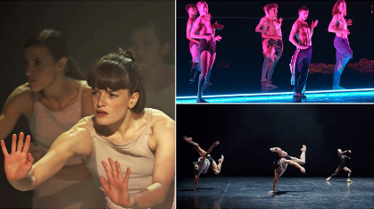
Currently BBC iPlayer is streaming an incredible amount of world class, professional dance as part of its ‘Dancing Nation’. This features dance performances from break dancing to ballet and everything in between.
Watching live theatre keeps us entertained but also encourages our creativity and understanding of the professional world. Choose some pieces to watch and analyse the choreography.

What is the choreographers intention?
How do they portray their idea through dance? What choreographic devices are they using?

You will be studying Rambert Dance as part of the A Level curriculum so get a head start!

Activity 2 - Start to build your portfolio!
You will be studying a vast array of choreographers during your time on the A Level Dance programme. Select some of the following (or all, if you want!) and give an insight in to their ‘four walls’. Gather research and build profiles on them and their contribution to the world of dance.

Be creative in how you present your work (posters, vlogs, slides etc).

Bob Fosse Akram Khan
Jasmin Vardimon Jerome Robbins Richard Alston

Activity 3 - Get Creative!
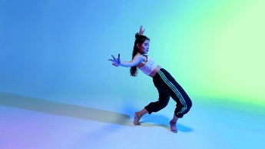
Write down some ideas about how you feel being within your ‘Four Walls’.
What dance style, movements, music, costume etc might you use to represent these feelings? Consider how you could present this work, try out some choreography and then perform it (safely!).
Film yourself doing it and send it over to our Instagram account for some feedback (@btc_padance – give us a follow whilst you’re there).

Activity 4 - Keep Dancing!
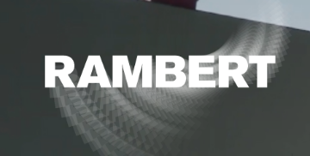
In the current situation, lots of dance companies, choreographers and schools are sharing their work online.
Take part in classes and use this time to develop yourself by learning a new style, keeping fit, increasing your strength, flexibility and creative skills. Rambert Dance have launched a new service called Rambert Home Studio - Rambert. They are delivering classes for all ages and abilities, go and take a class!
Youtube is also great for tutorials in different styles (contemporary, pilates, stretching, strengthening etc) – keep moving!

We can’t wait to get in the studio and start dancing with you all! If you have any questions about studying A Level Dance at BTC, head over to @btc_padance on Instagram and send us a message or you can email us on the addresses above.

