A Level Economics

Lecturer
Sabrina Schmidt schmidts@btc.ac.uk

Activity 1
Provide a written explanation answering the following questions:
What does this image mean to you?
What problems do you see here?
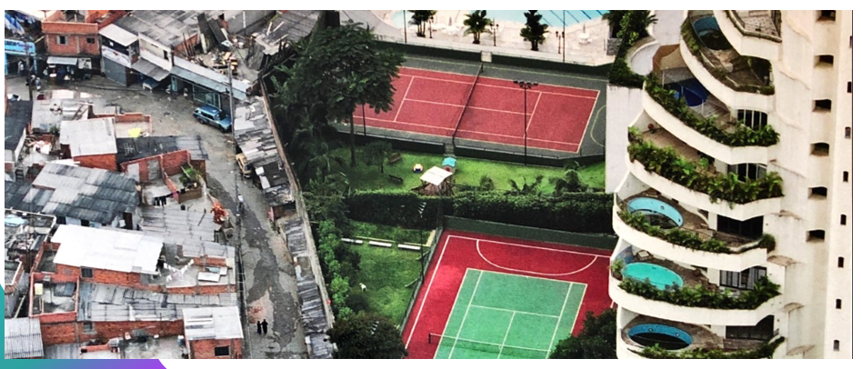

Activity 2
To compare living standards in each country, we use a measure called GDP per capita.
- GDP: Total value of everything produced in a period such as a year
- Per Capita: per person
- Height of line: An estimate of the average income at the date on the horizontal axis
Provide a written explanation to the following questions:
- What can you see in the graph on the next page and why?
- How do we expect this to change in the next 50 years?

