A Level Economics
Answer Sheet
Well done for completing your first Economic analysis. Check your answers with the suggested answers below.

Activity 1
You might have thought about the following:
- Inequality
- Unfairness
- Capitalism
- Absolute poverty
- Living standards
- Rich and poor
The image illustrates a very common problem of our more and more globalised and connected world. The difference between the poor and the wealthy increased exponentially in the past century and decades. In Economics, we will analyse reasons and consequences of it. We will explore situations and circumstances in different countries and analyse the differences between continents.

Activity 2
Living Standards: How have they changed and why are they important?
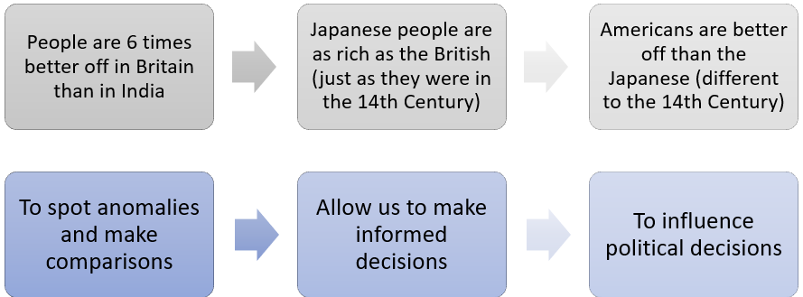

Economics is about…
How we come to acquire things that make up our livelihood (food, clothing, shelter).

How we interact with one another (Buyers, sellers, employers, employees, the government).

How we interact with the natural environment (Breathing, extraction of raw materials).

How each of these change over time.

