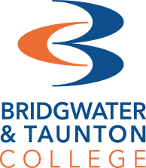

A Level French

Lecturer
Irena Hubble-Brezowski Hubblebrezowskii@btc.ac.uk
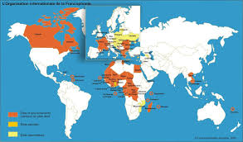

Activity
Voici une carte de la francophonie.
Petit Quiz de la Francophonie.
- Combien de pays dans le monde parle le français?
- Combien de pays en Europe parle le français?
- Où est-ce que tu voudrais voyager ? Et pourquoi?
- Quelle est la date de la journée internationale de la francophonie?
Salut! As you are checking out this page, you must a francophile!

I have asked you questions about francophonie because when you study A Level French, it is really important to know not just about France but all French- speaking countries round the world.
What a doubly exciting world it is, when you can speak French and English.
Knowing about festivals in France and French-speaking countries- ensures you achieve more marks in your exams AND widens your horizons! Get yourself ready for the course by doing this background research! Bonne chance!
Pourquoi les fêtes et les festivals sont importants en France et dans les pays francophones?
Le tourisme? Le patrimoine? L’histoire de la région?
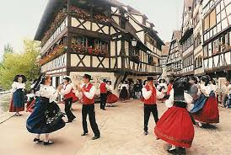
Le divertissement pour les jeunes et les familles?
Ecrivez 50 mots au sujet des fêtes
Ecoutez l’audio ci-dessus et testez –vous.
Les réponses sont inclus.
Bonne chance! https://www.bbc.co.uk/bitesize/guides/zknrxyc/test

Frequently asked questions
How is this subject assessed?
A Level French consists of three exams. Part 1 is designed to assess your speaking skills, involving a task card and Research Project. Paper 2 will test your listening, reading and translation skills. Finally, paper 3 is an essay style paper where you will write about a novel and film that you will study across the two years. In A Level French, the novel is ‘No et Moi’ by Delphine de Vigan and the film is ‘Intouchables’.

Is A Level French very different to GCSE?
A Level French is based upon the grammar and topics you will have covered at GCSE. The main difference between the two levels is the amount of culture that we explore at A Level. We have much more dedicated time at A Level to look further into the cultures and societies surrounding France and other French speaking countries, such as the province of Quebec in Canada, Senegal in West Africa, the island of La Réunion....

Do you have good links to universities?
If you study A Level Languages at BTC ,we have a great connection to many universities. Students have enjoyed visits to Bath University to sample what language learning is like at university. We have also been fortunate enough to receive visits from Oxford and Exeter universities who have hosted fantastic activity days on campus.
Current French students have taken part in the ‘Pathway to Bath’ programme, an online learning experience hosted by Bath University and as a result, gained a lower offer to study Languages at Bath University after A Levels. Our students are now studying languages at Sheffield, Leeds, Bath, Birmingham, Southampton, London UCL.

What trips do you offer?
We have run many successfully trips which have offered students a great opportunity to develop their language skills. We have travelled to Paris and Bruxelles to visit the European Parliament.

Recommended Netflix Series:
- Lupin
- Appelez mon agent
- Les Miserables.
- Recommended films on other platforms:
- Les Choristes
- Bienvenue chez les Ch’tis
- La Haine
- Intouchables
- Amelie
https://frenchflicks.com/read/items/the-35-best-french-films-of-the-decade-and-where-to-stream-them

Recommended Grammar Practice
- www.languagesonline.org.uk
- https://www.bbc.co.uk/bitesize/subjects/z9dqxnb
- www.wordref.com
- Duolingo
- Memrise

