A Level Geography

Lecturer
Lucy Watson Watsonl@btc.ac.uk

Activity 1 - Hazard map activity
Complete the hazard map on the following page.

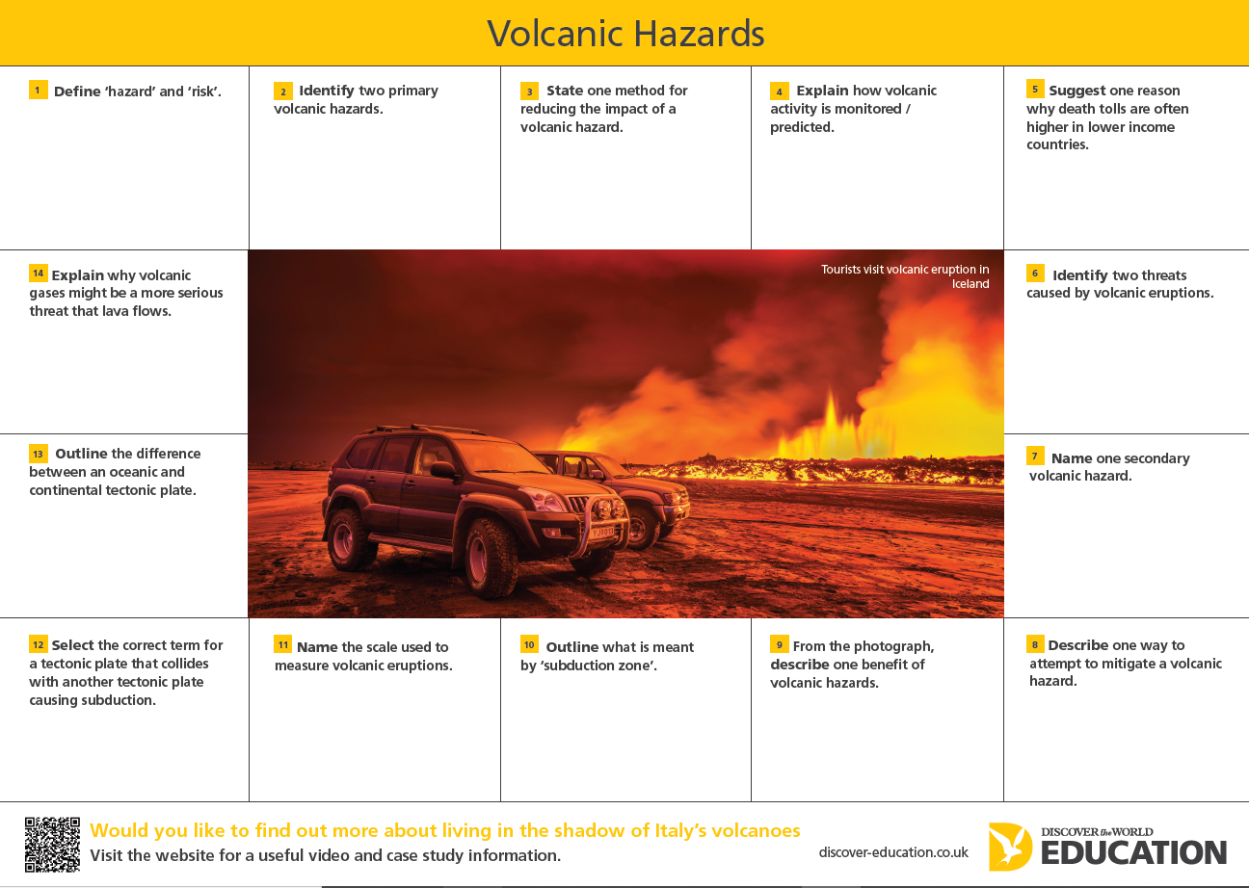

Activity 2 - Definitions
Speak like a Geographer! Our first module will be Changing Coastal Landscapes. To help prepare you for this module, research the definitions for the following types of coastal erosion:
- Hydraulic Action -
- Abrasion -
- Attrition -
Solution -

----------------------------------------------------------------------------------------------------------------------------------

Frequently asked questions
What trips / guest speakers are there?
In Geography there are 2 field trips in both the first and second year of the course. These may include a beach study at Sand Bay and Middle Hope, a look at urban redevelopment in Bristol, a woodland study on the Quantock Hills and a visit to the Environment Agency offices and pumping station to look at flood management in Somerset. In the past, we have had guest speakers from the Environment Agency and the Quantock Hills AONB.
Residential trips- we are usually able to offer an optional overseas residential trip each year. Previous destinations include Iceland and Italy. This year we are traveling to Italy and staying in Rome and Sorrento, visiting Pompeii, Vesuvius, the Colosseum and many other places of interest.

What other subjects does A Level Geography go with?
A Level Geography is a versatile subject the compliments study of many other areas. Students typically tend to study Geography alongside subjects such as Geology, Biology, Sociology, Law, Business and English.

Recommended Reading
Keep up to date with topical news, much of it links to Geography in some way whether it’s climate change, natural disasters, trade wars, piracy or politics!
https://www.theguardian.com/uk/environment
https://www.bbc.co.uk/news
(sections in Science, World and many others have relevant news articles)

Recommended watching
Perfect Planet (BBC iplayer);
Into the Inferno: With stunning views of eruptions and lava flows it captures the raw power of volcanoes (Netflix)
Planet Earth and Planet Earth 2: The Irreplaceable Sir David Attenborough explores some of the world’s different biomes (BBC iplayer)

Recommended Listening

https://podcasts.ox.ac.uk/series/school-geography-and-environment-podcasts

https://www.rgs.org/all/?categories=FreeToView&utm_source=Twitter&utm_medium=social&utm

