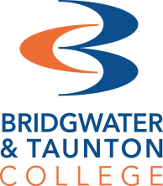

A Level History

Lecturers
Karen Crowley crowleyk@btc.ac.uk
Alex Martin Diaz martindiaza@btc.ac.uk
Matthew Smith smithm@btc.ac.uk

Activity 1 – Witchcraft source questions
For this this introduction task, we will look at a few sources about Witchcraft in Early-Modern Britain. Your response to these questions will be down to your own interpretation, so there is no ‘right’ or ‘wrong’ answers. Review each source, then fill in the table in respect of each of the sources.

Source 1
https://www.nationalarchives.gov.uk/education/resources/early-modern-witch-trials/results-of-an-exorcism/

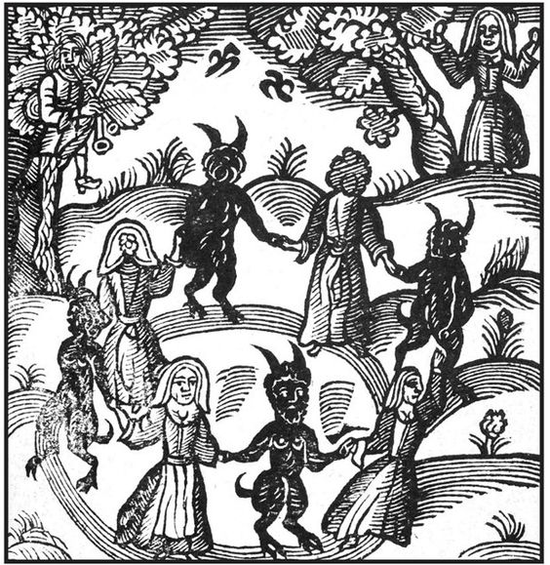
Source 2

Source 3
In 1597, King James VI of Scotland published a book on witchcraft called Daemonologie.
It was also published in England in 1603, when James acceded to the English throne.
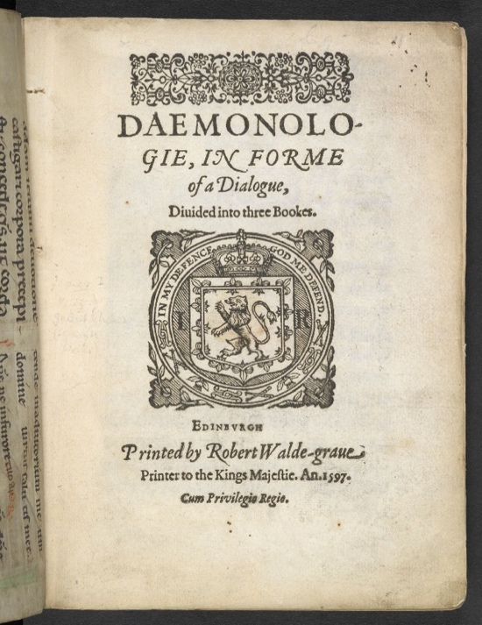
The book asserts James’ full belief in magic and witchcraft, and aims to both prove the existence of such forces and to lay down what sort of trial and punishment these practices merit, in James’ view, death.

Type of Source/ Content | Reliability | Utility

Now you have reviewed each of the sources, consider how you would answer the following question:
How useful are sources 1, 2 and 3 to the historian studying why the belief in witchcraft existed in Early Modern Britain?

Frequently asked questions
What will I study?
For the History A Level, we offer two differ routes, early-modern and modern history with different histories available for the first two exam papers. Paper two of the qualification is a source-based paper. Early Modern students will study the French Revolution, whereas Modern students will study Indian Independence.

How is it assessed?
History is assessed through three two-hour exams and a piece of coursework. The exams are all essay based and throughout the two years of study prior to the exam, you will receive teaching based on the skills needed to sophisticatedly answer questions in this style. The coursework is completed at the start of your second year of study, this is a 3,000 to 4,000 word essay on any subject of your choice (excluding work covered in Paper One).

I really love History! Can I take Early-Modern and Modern history?
Unfortunately, you can only take one of the A Level History option at BTC. Both routes are the same qualification, just with different histories chosen.

What other subjects does A Level History go with?
History complements a wide range of subjects. History students usually take other humanity-based subjects such as Politics, Law, Sociology and English. However, History also complements any combination of subjects.

Recommended reading
https://www.tutor2u.net/
History/blog
This blog is really good for reading a few information inputs of historical arguments and events. Sometimes they put free revision tools there too! If you find a revision tool, check in with one of us, and we will let you know if it is worth taking a look! 😊

Recommended watch list
Netflix/ iPlayer etc
For your coursework, you can choose any topic you like (excluding Paper 1 and you want to make sure that you can get enough historians writing about it!) So, have a browse through the history documentaries and pick out anything that interests you - the more knowledge you have on topics, the more options you have when it comes to coursework!

