A Level Maths and Further Maths

Lecturers
Sam Nash nashs@btc.ac.uk
Adrianna Johnson johnsona@btc.ac.uk
Emily Page-Symonds pagesymondse@btc.ac.uk

Activity 1
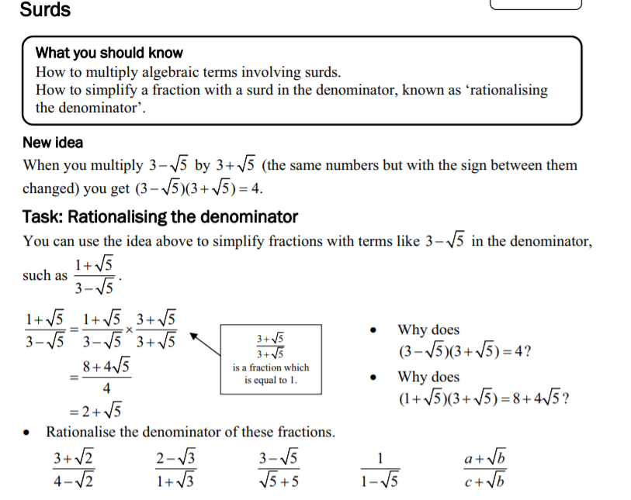
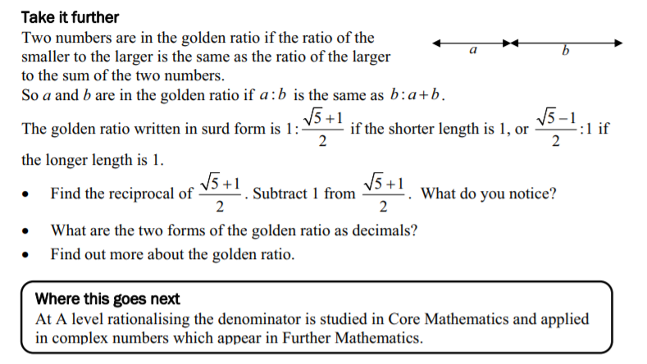

Activity 2
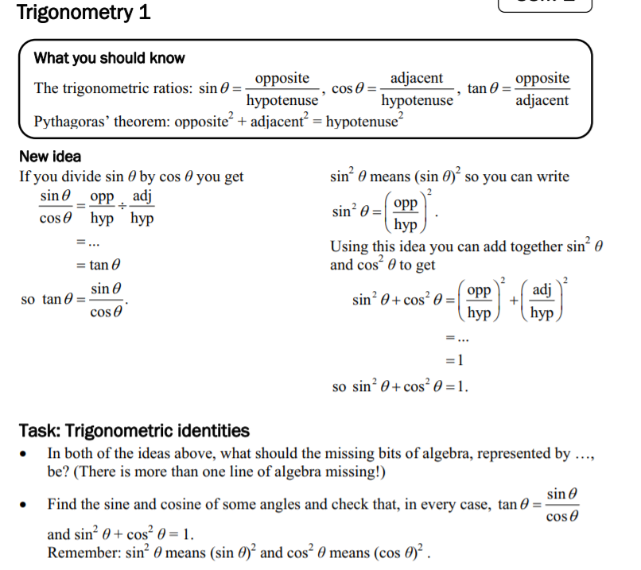
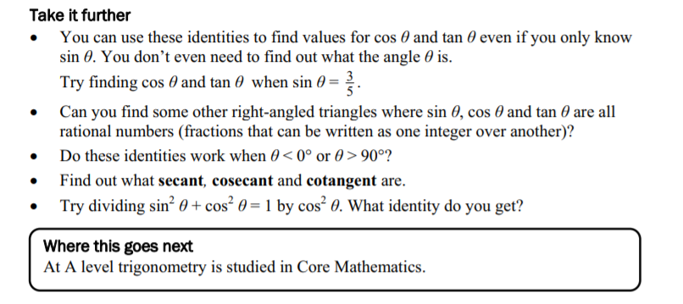

----------------------------------------------------------------------------------------------------------------------------------

Frequently asked questions
How are these subjects assessed?
A Level Maths is assessed via 3 two-hour exams. A Level Further Maths is assessed via four 1 hour and 30 minute exams. Throughout the course, we thoroughly prepare you for the exams with skills development, exemplar answers and practice questions.

What skills will I get from studying A Level Maths?
By studying Maths at A Level, you will develop skills, such as problem-solving, analytical skills, research skills and logic.

What other subjects does A Level Maths go with?
Maths is a versatile subject that pairs well with several other numbers-based subjects. It can be studied with sciences such as Chemistry, Biology or Physics, or subjects such as Economics, Accounting and Finance, and IT. Maths also pairs easily with other subjects, like English or History.

What topics would I learn about?
Differentiation, Integration, more understanding of vectors, mechanics and statistics, the biggest focus is on Pure Maths, trigonometry

Where can the qualification take me?
Maths can play an integral part of many careers, and can provide numerous opportunities, both academically and career-wise. Studying A-Level Maths can open the door to a number of careers, such as Construction and Architecture, Medicine and Scientific Research, Teaching and Tutoring, Games Development and many more. A wide range of careers require Maths skills, such as finance, science and IT.

Recommended Reading
“Fibonacci’s Rabbits and 49 other discoveries that revolutionised mathematics” by Adam Hart-Davis
“Mathematics – from creating the pyramids to exploring infinity” by Anne Rooney
“The Joy of x” by Steven Strogatz
“Zero: The Biography of a Dangerous Idea” by Charles Seife
“Prelude to Mathematics” by W.W. Sawyer
“Proofs from The Book” by Aigner and Ziegler

Recommended Listening
Travels in a Mathematical World
A podcast by Peter Rowlett, Institute of Mathematics and its Applications, featuring mathematicians talking about their work as well as features on maths history and maths news.

A brief history of mathematics
Professor of Mathematics Marcus du Sautoy reveals the personalities behind the calculations and argues that mathematics is the driving force behind modern science.

