A Level Photography

Course Leader
Jake Elson elsonj@btc.ac.uk
Lecturers
Joe Coleman
Steve Welsh
Technical Support
Graham Cook

This document contains some tasks that will help you explore photography in preparation for starting your course with us in the Autumn. The tasks set should help you start to develop your own ideas and concepts which is a key area of the course, but also provide an opportunity for research and creativity. They are also designed to be fun whilst you are not currently in a formal educational setting.

If you need any help or guidance please feel free to email the course leader, then just bring any work with you at the start of the course.

Key Course Information | Keep in Touch
Duration  2 years  Awarding body  OCR  Qualification  A Level Art & Design (Photography pathway) | To gain access to new resources, information and to stay connected, please request to join our Facebook group and follow our Instagram feeds.  FACEBOOK  Photography BTC  (black and white montage photoS)  INSTAGRAM  @btc_photo  @btc_creativearts

Brief – ‘These 4 Walls’

Context
The COVID-19 global pandemic has seen most of us spending more time, possibly confined completely to the ‘4 walls’ we call home. In this time of distant learning we task you to find inspiration amongst the everyday in preparation for your Creative Arts A Level in Photography

There are suggestions for tasks to complete, research opportunities and further reading/ watching listed below. This work will form the basis of the induction project at the beginning of the Autumn term, and we hope to put on an initial exhibition for your course alongside the other visual arts A Levels. That said, this isn’t something to worry about. We understand everyone is in a unique situation at the moment, so please do what you can and get in touch if you need to!

You should explore themes related to the brief of ‘THESE 4 WALLS’. You can determine your own direction but to help you get started you might want to begin with one of the following:

DIRECTION | CONCEPT | ARTIST
Portraiture | You could look at who you are sharing this lockdown with.  Portraits do not need to always include the person, think about creating a portrait using items that reflect the persons’ personality or even a pet.  If you have willing participants (pets included) why not shoot some portraits? | Dorothea Lange
Suggested equipment  DSLR  Camera phone  Film camera |  | 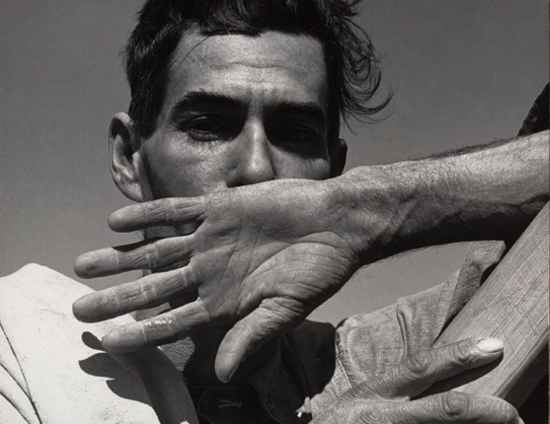
Still Life | Everyday objects carry their own beauty and often have some very aesthetically pleasing lines and shape. Maybe the object just reflects light well once a day, whatever it is inanimate objects can carry photogenic qualities.  This can make for some interesting opportunities to get creative with photography | Man Ray
Suggested equipment  DSLR  Camera phone  Film camera |  | 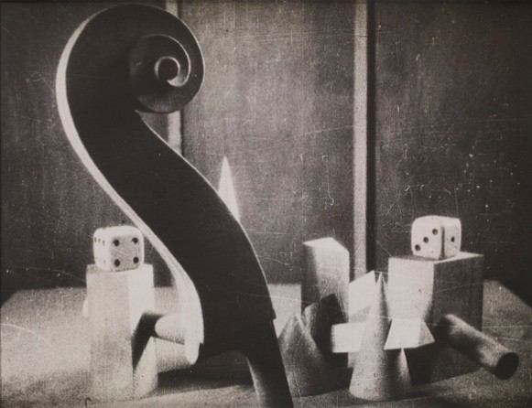
Montage | This idea may be a little harder to pull off as you may require the use of software although this can be achieved if shooting on film. Why not gather the images you wish to merge now and then we can help you with the montage in September?  When done well montage images can really play with the spectator’s perception. | Thomas Barbéy | David Hockney
Suggested equipment  DSLR  Camera phone  Film camera |  | 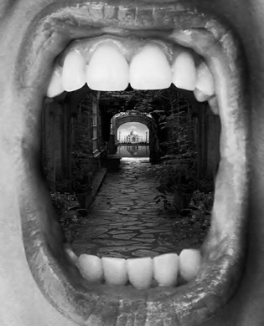 | 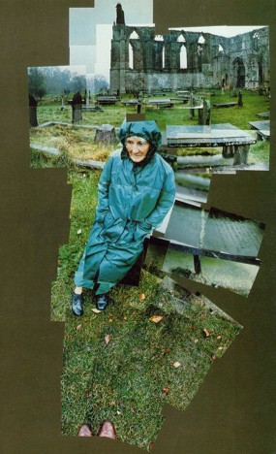
Architecture | Your own home, outbuildings, neighbourhoods, open spaces (deliberate lack of architecture) or nearby religious structures can provide for creative architectural photography.  Thinking about structures as art forms can be an interesting analysis of your surroundings. | Hilla Becher
Suggested equipment  DSLR  Camera phone  Film camera |  | 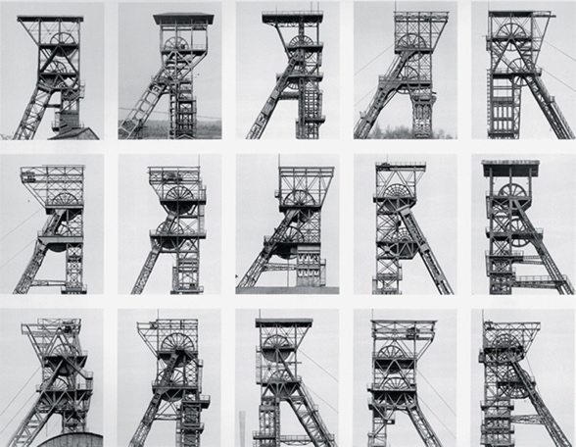
Shooting on Paper | Now this could come with a little cost.  You can purchase photo sensitive paper (Ilford is recommended) and you can capture photos without a camera. This paper is widely used in pinhole, photograms and chemigrams.  You can make a pinhole camera out of a tin or container of any size and shape. Remember this paper is light sensitive so has to be handled under a safe light (red light) or in complete darkness.  Check below for some links to how you can do this.  *Check the links below | Justine Quinnell
Suggested equipment  Tin can  Cardboard box  Foil  Pin  Trays full of water  Light sensitive paper  Red light (I use a Sainsburys carrier bag over a light) |  | 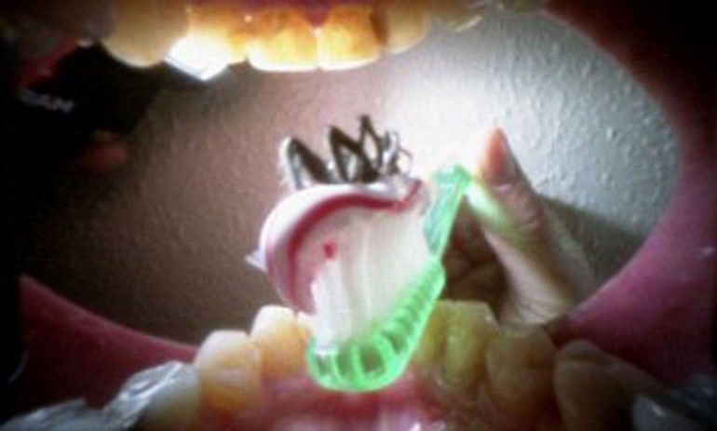

Making a pinhole camera and developing chemicals - www.rigb.org/docs/pinhole_camera_instructions_v5_0.pdf

Light sensitive paper - www.ilfordphoto.com/kentmere-vc-select-luster-sheets

How to create a photogram - www.bbc.co.uk/bitesize/guides/zgwpnbk/revision/10

Practical Tasks

- RECORD: produce studies relating to your chosen direction. This could include photographs, drawings, paintings, rubbings, sculptures, collages.
- ARTISTS: Find artists/designers that could relate to your initial ideas. Collect an image of the work and write about how they use materials, techniques, colours, textures, shape, line etc. within their work to communicate their ideas.
- CREATE: Use resources you have available to produce experiments and/or design ideas for practical work related to your theme. Some ideas include dying or painting with natural ingredients, printing with household objects, using different drawing techniques eg. continuous line, non-dominant hand etc.
- Using packaging from food stuffs or deliveries, up cycling objects/clothes/textiles.
- EXPLAIN: annotate your thought process throughout. Describe techniques and processes, link back to your theme and explain what you intend to communicate.

Resources that may be useful or inspirational

- Pictures from Home - http://larrysultan.com/gallery/pictures-from-home/
- British Journal of Photography - https://www.bjp-online.com
- Photography at the V&A - https://www.vam.ac.uk/collections/photographs
- Martin Parr Foundation - https://www.martinparrfoundation.org

