A Level Physics
Answer sheet

Activity 1 - SI units

- 2.176x10⁻¹⁸J
- 9.6x10⁻¹⁹C
- 3.47x10⁻²⁵ kg
- 4.752x10⁶ s
- 4.011x10¹⁶m

Activity 2

The Sun is about 4.5 billion years old. it has used up about half of its nuclear fuel (hydrogen). In about 5 billion years from now, the sun will begin to die.
As the Sun grows old, it will expand. As the core runs out of hydrogen and then helium, the core will contract and the outer layers will expand, cool, and become less bright. It will become a red giant star.
After this phase, the outer layers of the Sun will continue to expand. As this happens, the core will contract; the helium atoms in the core will fuse together, forming carbon atoms and releasing energy. The core will then be stable since the carbon atoms are not further compressible.
Then the outer layers of the Sun drift off into space, forming a planetary nebula (a planetary nebula has nothing to do with planets), exposing the core.
Most of its mass will go to the nebula. The remaining Sun will cool and shrink; it will eventually be only a few thousand miles in diameter!

The star is now a white dwarf, a stable star with no nuclear fuel. It radiates its left-over heat for billions of years. When its heat is all dispersed, it will be a cold, dark black dwarf - essentially a dead star (perhaps replete with diamonds, highly compressed carbon).
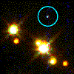
A White dwarf star: (circled) in the globular cluster M4.

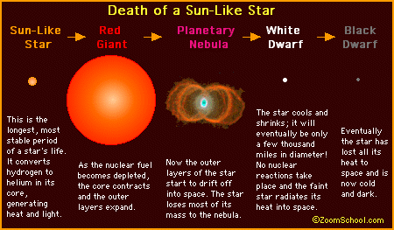

https://www.enchantedlearning.com/subjects/astronomy/sun/sundeath.shtml

