A Level Spanish

Lecturer
Sarah Heal heals@btc.ac.uk

Read the attached text on ‘La Tomatina’ and answer the questions below. Please also follow the link to a youtube video which shows your more about this fiesta.
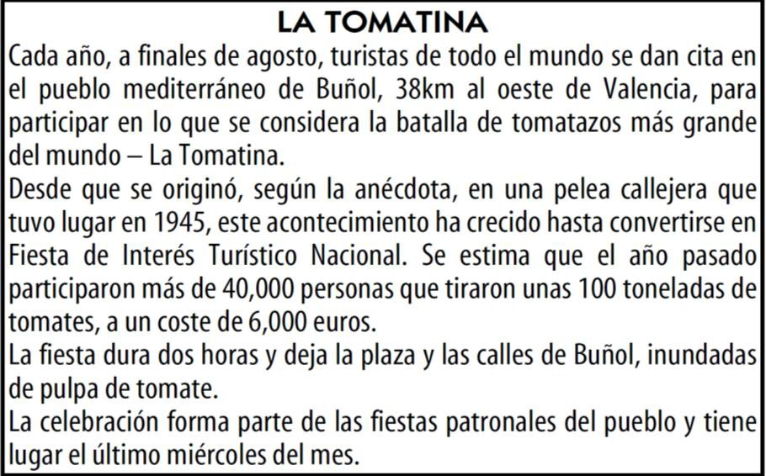
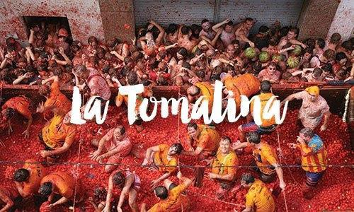
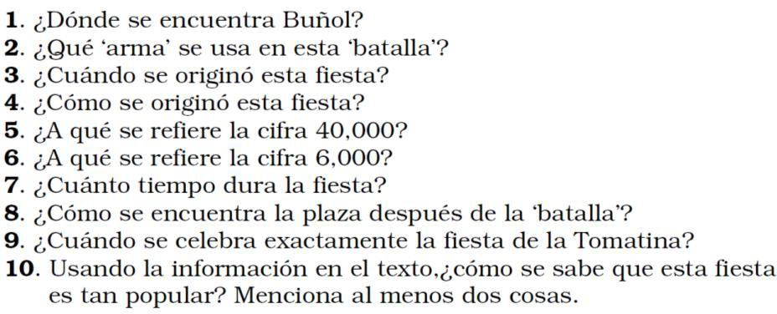

https://www.youtube.com/watch?v=jvUOYtln23s

Frequently asked questions

How is the subject assessed?
A Level Spanish consists of three exams. Part 1 is designed to assess your speaking skills, involving a task card ad Research Project. Paper 2 will test your listening, reading and translation skills. Finally, paper 3 is an essay-style paper where you will write about a novel and film that you will study across the two years.

Is A level Spanish very different to GCSE?
A Level Spanish is based upon the grammar and topics you will have covered at GCSE. The main difference between the two levels is the amount of culture that we explore at A Level. We have more dedicated time at A Level to look further into the cultures surrounding Spain and other Spanish speaking countries.

Do you have good links to universities?
BTC has a great connection to many universities. Students have enjoyed visits to Bath University to sample what language learning is like at university. We have also been fortunate enough to receive visits from Oxford and Exeter Universities who have hosted fantastic activity days on campus.

Current students have even taken part in the ‘Pathway to Bath’ programme, which is an online learning experience hosted by Bath University and as a result, gained a lower offer to study at Bath University after A Levels.

What trips do you offer?
We have run many successfully trips which have offered students a great opportunity to develop their language skills. Students have spent a week in Spain completing work experience in varying fields which has enabled them to gain some invaluable language skills alongside forming friendships and better cultural understanding.

Recommended Netflix series
- Paquita Salas
- Como caído del cielo
- Siempre bruja
- La boda de la abuela
- Las Chicas Del Cable
- La casa de papel
- Gran Hotel
- Velvet
- La catedral del Mar
- Elite
- La casa de flores

Recommended grammar practice
Languages online www.languagesonline.org.uk
Lightbulb languages http://www.lightbulblanguages.co.uk/resources-sp-al.htm
Study Spanish http://www.studyspanish.com/tutorial.htm
Spanish Dict https://www.spanishdict.com
Conjuguemos https://conjuguemos.com

