**Do you want to find a Snowman ?**

**Your challenge is to find and name all the snowman that are hiding around Vivary park**

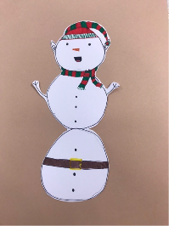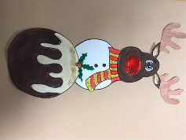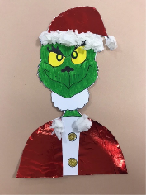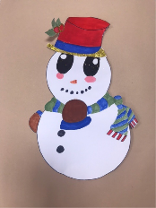

**_________ ________ _________ ________**

****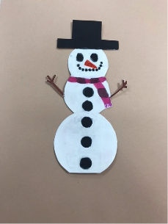

**________ ___________ ___________**

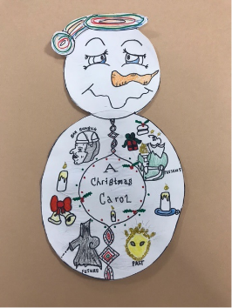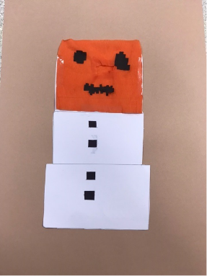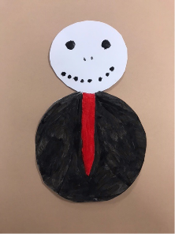

**_________ ___________ ____________**

This event has been organised by students studying T-Level in Education and Childcare at Bridgwater and Taunton College. The trail will run from 1st December 2021 – 6th January 2022. Trail sheets can be collected from the Visit Taunton Centre or downloaded from the college website.

[14275](https://uk.virginmoneygiving.com/fundraiser-display/showROFundraiserPage?pageId=%201214275)