**Easter Egg Hunt**

**Can you find all the hidden eggs to crack the code ?**

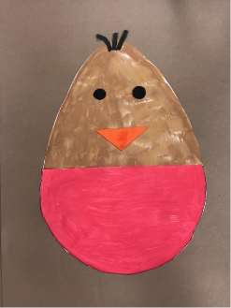 

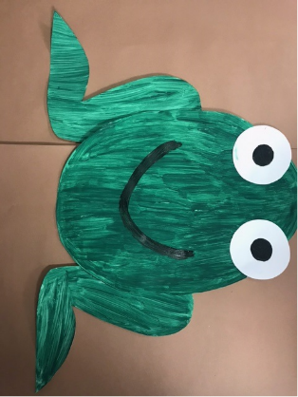**_________ _________ ________**

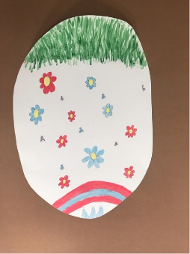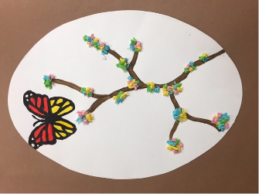

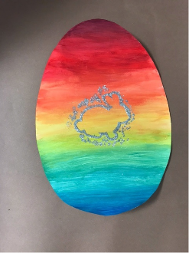**_________ _______ ______**

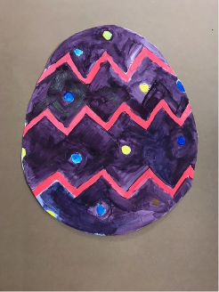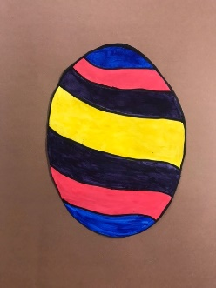

**_________ ________ ________**

This event has been organised by students studying Education and Childcare at Bridgwater and Taunton College. The trail will run from 6th April – 25th April 2022. Trail sheets can be collected from the Visit Taunton Centre or downloaded from the college website. Students would like to raise money for children in Ukraine. Please scan the QR code and make a donation of your choice to UNICEF to protect children in Ukraine.

[14275](https://uk.virginmoneygiving.com/fundraiser-display/showROFundraiserPage?pageId=%201214275)